caEHR

Performance Test Plan
Phase1 – Component Level

Author : Dale Sheppard
Ekagra Software Technologies, Ltd
Team : caEHR QA
Subcontract : 29XS223STO1

Document Change History
Version Number | Date | Contributor | Description
V.01 | 5/3/2010 | Dale Sheppard | Initial draft
V1.0 | 5/21/2010 | Dale Sheppard | Final Version 1.0


Updated June 22, 2010
Table of Contents

1 Introduction 2
1.1 Project Overview 2
1.2 System Overview 2
1.3 Document Overview 2
1.4 Relationship to Other Documents/Plans 2
Scope 2
1.5 2
1.6 Performance Test Objectives 3
1.7 Roles and Responsibilities 3
1.7.1 PMO – Project Management Office 3
1.7.2 Requirements DSL/Stream 3
1.7.3 Architecture DSL/Stream 3
1.7.4 Development DSL/Stream 4
1.7.5 Deployment DSL/Stream 4
1.7.6 QA DSL/Stream – Performance Test 4
1.8 Assumptions 5
1.9 Constraints 5
2 Performance Test Strategy 6
3 Workload Characterization 6
4 Test Environment Preparation 7
5 LoadRunner Script Development 7
6 Test Execution & Monitoring 7
7 Results Reporting 7

Introduction
This performance test approach document describes the appropriate strategies, process, workflows and methodologies used to plan, organize, execute and manage Performance Testing aspects of the Center for Biomedical Information and Information Technology (CBIIT) Ambulatory Oncology Electronic Health Record (caEHR) project.

Project Overview

The goal of the caEHR project is to support the Ambulatory Oncology sector, in the delivery of improved patient care through the development of consensus based health IT standards and solutions that meets this sectors unique EHR needs.

System Overview
The caEHR project will develop service specifications that will be adopted in the Ambulatory Oncology sector to meet the unique EHR needs of that sector to provide improved patient care.

Document Overview
This Performance Test Plan defines the approach to be used to validate that the caEHR services provide acceptable levels of performance while under realistic but heavy levels of system load. The main focus is to provide a description of the specialized activities related to analyzing, constructing, executing and documenting the Performance Tests and their results.

Relationship to Other Documents/Plans
This document expands on the caEHR Master QA Plan, section 4 Verification Testing, section 4.4.4 Performance and Load Testing.

Scope
This document only covers the Performance and Load Testing approach for the component testing of the individual Services and their associated Operations. Two categories of tests will be performed for the component services:

- Benchmark Tests – Fixed Number of Users and Transactions
- Degradation Tests – Increasing Levels of Users and Transactions to identify system limits

There will be additional phases of Performance Testing required for Use Case implementations of the services and during Reference Implementations. These phases will be covered in individual load test plans for those implementations.

Performance Test Objectives
There are two primary objectives for this component round of performance tests:
1) Benchmark Tests – execute each individual caEHR Service with the same fixed number of users and transaction loads and document the relative performance of each service.
2) Degradation Tests - execute each individual caEHR Service with increasing numbers of user and transaction loads and document the degradation of the services under load.

In support of these objectives, produce specific performance metrics that identify performance issues and bottlenecks relative to each service tested. Provide this information to the development team so that they have actionable information to size and tune the production system appropriately.

Roles and Responsibilities

PMO – Project Management Office
Responsible for:
- Assuring timely delivery the system/application
- Managing schedule and resources within project constraints
- Enforcing proper software development practices
- Providing adequate status reporting and project visibility to stakeholders

Requirements DSL/Stream
Responsible for:
- Developing Use cases and requirements in collaboration with the key stakeholders. These will be used as the basis to define the service specifications (including the Conceptual Functional Service Specification, Platform Independent and Platform-specific specifications).
- Identifying and documenting functional and non-functional requirements in Use Cases (which are composed of various modeling artifacts) for tracking through architecture, development and testing

Architecture DSL/Stream
Responsible for:
- Developing the Conceptual Functional Service Specification (CFSS)
- Developing the Platform Independent Model (PIM) and Platform-specific (PSM) service specifications
- Architectural Non-functional requirements
NOTE: The service specifications will also contain the functional and non-functional requirements of the service in the terms of conformance statements. These conformance statements represent the testable requirements of the service. Conformance statements should be traceable back the original use cases and requirements.

Development DSL/Stream
Responsible for:
- Developing the SAD – Software Architecture Document
- Completing the PSM – Platform Specific Model
- Developing the system/application or services
- Conducting unit and integration testing, including creation of associated test scripts

Deployment DSL/Stream
Responsible for:
- Collecting Deployment use cases and requirements for each site and assuring they are adequately reflected in the project’s analysis artifacts
- Describing the Deployment scenarios for each site
- Executing the Deployment at each site
- Managing the interaction with the NCI/CBIIT-designated Cancer Center (known as NCI Community Cancer Center Program (NCCCP) selected and funded by CBIIT to undertake formal adoption, or adaptation of caEHR artifacts (specifications or software):
- Contribute to Use case, requirement development through review
- Unique and specific requirements for their site
- Deployment at their site
- Conduct Full User Acceptance, and end-to-end testing; this includes identifying testing scenarios, building the test scripts, executing scripts and reporting test results

QA DSL/Stream – Performance Test
In the context of Performance Testing, responsible for:
- Developing the Performance Test Plan and Schedule
- Documenting the system Workload assumptions and response time requirements
- Creating the LoadRunner Scripts and test data for the scripts.
- Executing the Performance Tests.
- Work with the Development Team to isolate bottlenecks and tune the system accordingly.
- Document the Performance Test results.

Assumptions

- System workload requirements will be provided by the team responsible for Non-Functional requirements.
- Response Time requirements will be provided by the team responsible for Non-Functional requirements.
- A separate, stand-alone Performance Test environment will be provisioned by the Continuous Integration team for each deployment.
- Service Test or Soap UI scripts will be provided to the Performance Tester for Services that have already passed functional testing.
- Development will dedicate a resource to each test execution (2 hour run) that will help Monitor and Diagnose performance bottlenecks as they occur.

Constraints
The Performance Test environment may not match the capacity (CPU, Memory, Connection Pools, Disk architecture, etc) of the targeted Production environment or the capacity of the production environment may not be known.

The results of the performance tests may not be valid without a properly sized test environment.

Performance Test Strategy

The basic strategy during this first round of Component level performance tests is to identify the relative performance of each Service under a common set of load assumptions. Two categories of tests will be performed, benchmark and degradation tests. In this way we will be able to identify which services perform relatively well and those which perform poorly for a given set of load assumptions.

Subsequent rounds of Performance Testing will include Use Case testing for logically related Sets of Service/Operation calls and also Reference Implementation tests for the initial Deployment sites for caEHR services. These tests will be covered in separate Performance Test Plan documents because all of the sections will be different for these test, Workload Assumptions, Test Environments, etc. will all be different.

In order conduct these initial Component level load tests, a standard set of analysis and preparation activities need to be completed:

- Workload Characterization
- Test Environment Analysis and Preparation
- LoadRunner Test Script Development
- Performance Test Execution and Monitoring
- Results Reporting

These activities are documented in the following sections.

Workload Characterization
There are two categories of Performance Requirements we generally look for, Workload Expectations and then Response Time Expectations for that workload. The Workload Expectations usually reflect the expected transaction volume for the Services and the Response Time Expectations reflect the requirements for response times while the system is loaded with the expected transaction volumes. Since we don’t have those expectations yet, we will use a Benchmarking approach and a scaled Degradation approach.
The examples below are samples from the Workload Characterization Matrix. The real matrix will be updated with ALL of the Web Servcies and operations as they are available to be tested.
Benchmark Workload Expectations:

WEB SERVICE | OPERATION | # of User  Connections/Hour | # of Transactions  per Hour
Referral Consult | createReferralOrder | 100 | 600
 | queryReferrlaResult | 100 | 600
 | replaceReferralOrder | 100 | 600
 | replaceReferralOrder | 100 | 600
Benchmark Response Time Expectations:

WEB SERVICE | OPERATION | Expected Response Time (Seconds)
Referral Consult | createReferralOrder | 5
 | queryReferrlaResult | 5
 | replaceReferralOrder | 5
 | replaceReferralOrder | 5

DEGRADATION Workload Expectations:

WEB SERVICE | OPERATION | # of User  Connections/Hour | # of Transactions  per Hour
Referral Consult | createReferralOrder | 100, 500, 1000 | 600, 3000, 5000
 | queryReferrlaResult | 100, 500, 1000 | 600, 3000, 5000
 | replaceReferralOrder | 100, 500, 1000 | 600, 3000, 5000
 | replaceReferralOrder | 100, 500, 1000 | 600, 3000, 5000
DEGRADATION Response Time Expectations:
Will be the actual Transaction Response Times recorded for each setoff load.
We will repeat the above for all of the Service/Operation pairs.

Test Environment Preparation

The equivalence of the load test environment to the actual production environment is critical to the accuracy of the results of load and performance testing. If the test environment is not sized from a server hardware, OS, software configuration and database size perspective then the load test results will not accurately reflect the production results. With this in mind, documented below is our current understanding of the Test Server configuration and the targeted Production Server configuration.

The QA Team is reliant upon and working with the Deployment Team to define the performance test environment requirements based on deployment sites.

PERFORMANCE TEST ENVIRONMENT

Environment Component | Description | Size | Counters
Amazon ec2 Cloud Server Container | Linux – Fedora Core 8
 | CPUs | ?
 | Total Memory | 1.7 gig
 | Free Memory | 5.2 meg
Application Servlet Container | Tomcat 6.0.20
 | JVM(s)
 | Connection Pool
 | HeapSize
Database Server | PostgreSQL 8.2.5 | ?
Number and size of tables | ??

More environment specifics:
Fedora Core 8. Here's some specifics...
[hudsonuser@domU-12-31-39-10-64-28 logs]$ uname -a
Linux domU-12-31-39-10-64-28 2.6.21.7-2.fc8xen #1 SMP Fri Feb 15 12:39:36 EST 2008 i686 i686 i386 GNU/Linux
[hudsonuser@domU-12-31-39-10-64-28 logs]$ cat /etc/redhat-release
Fedora release 8 (Werewolf)

[hudsonuser@domU-12-31-39-10-64-28 caehr-esd-war-webapp]$ cat /proc/meminfo
MemTotal: 1747764 kB
MemFree: 519384 kB
Tomcat 6.0.20
Looks like default configuration (no memory parameters, etc...). Should probably verify that with CDO though.
Sun JDK 1.6.0-14
PostgreSQL 8.2.5 on i386-redhat-linux-gnu, compiled by GCC gcc (GCC) 4.1.2 20070821 (Red Hat 4.1.2-25)

LoadRunner Script Development
LoadRunner test scripts will be developed for each Release/Iteration/Sprint. Once The Service Test scripts are executed and passed, that will be the hand-off that the LoadRunner Scripts for that Sprint can be developed. The basic flow of test scripts will be:
Manual Test Script in Quality Center
Automated Test Script w/ Service Test
LoadRunner Script w/ VU Gen (SOA)

Additional data variation will be added to the LoadRunner scripts to prevent server caching and false positive response time results.
Service Test 9.5 evaluation does not support WSDL 2.0 and was unable to import the first WSDL that was delivered by Architecture. A Services Test 11.0 beta version is being provided to us by HP which is suppose to support WSDL 2.0. The initial LoadRunner evaluation was conducted using a WSDL provided by development which did not employ the complexities supported by WSDL 2.0.

Test Execution & Monitoring
The Performance Test schedule is in JIRA and is part of the caEHR QA Master schedule. Reflected in this schedule is the iterative execution of performance test cycles. Each cycle will contain scripts for the Services and Operations that are available for that Release/Iteration/Sprint.

For each test cycle, a standard set of results reports will be presented to the project team. The categories of reports will reflect both the Benchmark and Degradation test response times and system resource utilization. Samples of these reports are presented below.

Results Reporting

For each Sprint and associated Performance Test Cycle, a series of LoadRunner Analysis Reports will be produced. Samples of 3 of the reports are:

- Transaction Response Times
- Transaction Performance Summary
- Transaction Response Time Under Load

Samples are provided below:

TRANSACTION RESPONSE TIME

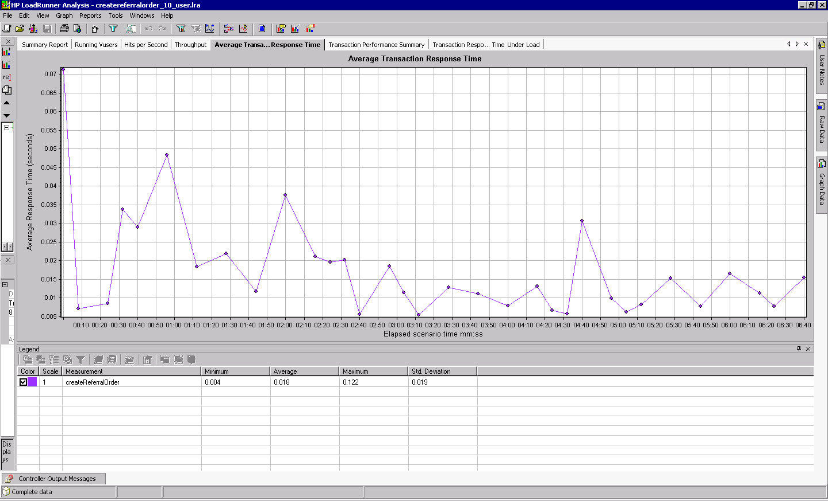

Transaction Performance Summary
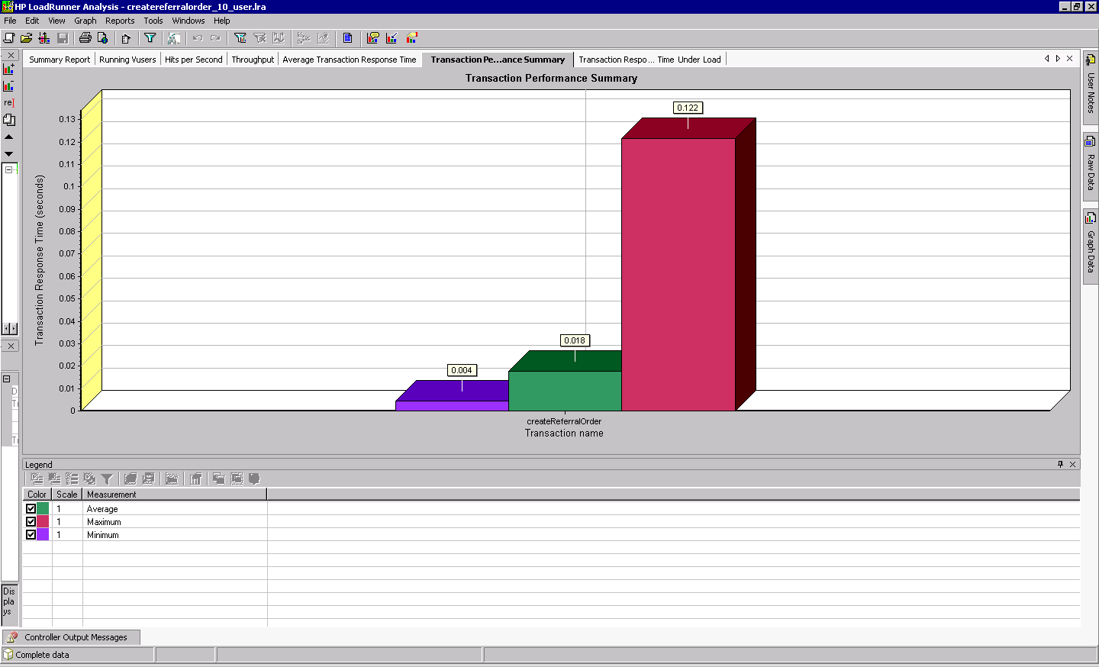

Transaction Response Time Under Load

